**LANGUAGE DEVELOPMENT FOR BABY CLASS 3 – 4 YRS TERM ONE 2023**

**WEEK I (ORIENTATION WEEK)**

**LESSON 1**

**(Activities)**

Actions examples

Jumping clapping

Standing sitting

Sitting waving

**LESSON II**

**Activities**

Telling their names

Telling their school age

Class and sex

**LESSON III**

**Activities**

Recognition

Picture reading

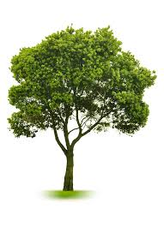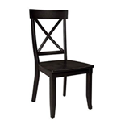**Telling pictures orally**



**Telling pictures**

**Activities**

-Identification

-Naming

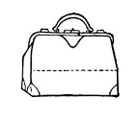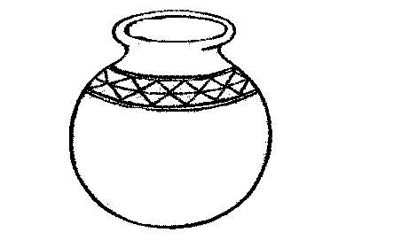-Observation

**Lesson II**

**Activities**

-Recognition

-Naming

-Circling the same pictures

Circle the same

|  |  |  |
| --- | --- | --- |
|  |  |  |
|  |  | https://encrypted-tbn0.gstatic.com/images?q=tbn:ANd9GcRWKIbNTkHzXmw9vwsybpOj-zRLr0AdlE53K8SRbUlwsNDyYq2_oQ |
|  |  |  |
|  |  |  |

**Lesson III**

**Activities**

-Identification

-Recording

-Recitation

-Circling the given picture

**Circle the given picture**

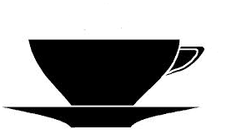

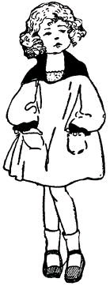







**Week 3**

**Lesson 1**

**Activities**

-Rhyming

-Singing

-Sharing

-Naming pictures

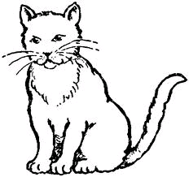Telling pictures



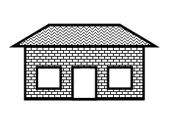

**Lesson II**

**Activities**

-Articulation

-Recognition

-Naming

-Shading

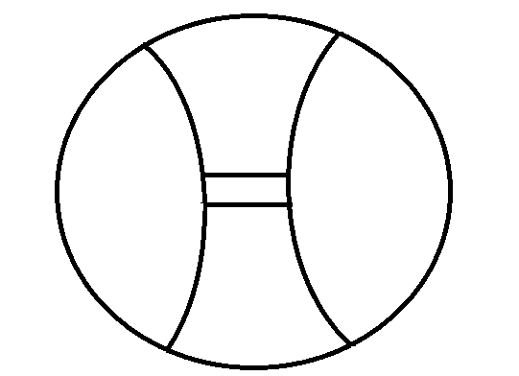**Shade**

**Lesson III**

**Activities**

-Identification

-Sorting

-Naming

-Tracing

**Trace**

**Lesson IV**

**Activities**

-Rhyming

-Identification

-Shading

**Shade**

**Week 4**

**Lesson I**

**Activities**

-Singing

-Identification

-Naming

-Tracing

Trace

**Lesson II**

**Activities**

-Identification

-Articulation

-Naming

-Matching

**Match**







**Lesson III**

**Activities**

-Identification

-Naming

-Sorting

-Matching

Match









**Lesson IV**

**Activities**

-Singing

-Recognition

-Naming

-Drawing

Drawing

**WEEK 5**

**Lesson I**

**Activities**

-Recitation

-Identification

-Naming

-Shading the same pictures

**Shade the same**







**Lesson IV**

**Activities**

-Recognition

-Circling the given picture

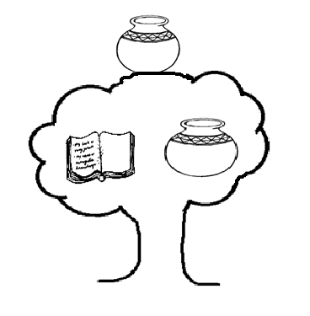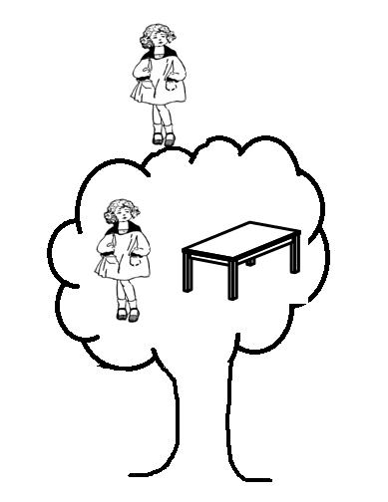Circle the given picture

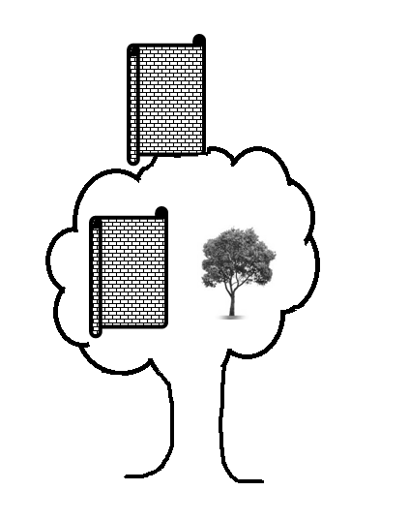

**WEEK 6**

**Activities**

-Sorting

-Articulation

-Naming

-Putting the missing parts

**Put on the missing part**

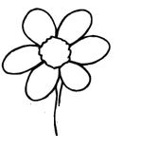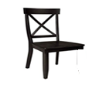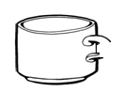

**Lesson II**

**Activities**

-Recognition

-Naming

-Singing

-Putting the missing parts

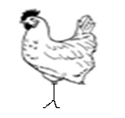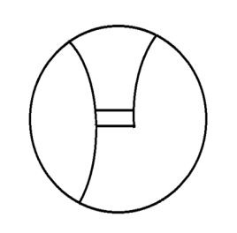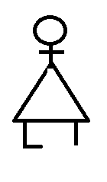**Put on the missing parts**

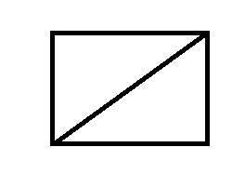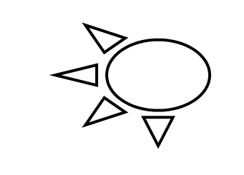

**Lesson III**

**Activities**

-Identification

-Naming

-Drawing

Copy and draw

|  |  |
| --- | --- |
|  |  |
|  |  |

**Lesson IV**

**Activities**

-Recognition

-Recitation

-Naming

-Drawing

**Copy and draw**

|  |  |
| --- | --- |
|  |  |
|  |  |

**Week 7**

**LESSON I**

**Activities**

-Singing

-Rhyming

-Sharing

-Articulation

-Naming

-Drawing

**Copy and draw**

|  |  |
| --- | --- |
|  |  |
|  |  |

**Lesson II**

**Activities**

-Identification

-Naming

-Matching

-Drawing

**Match the same**











**Lesson III**

**Activities**

-Recitation

-Articulation

-Naming

-Recognition

-Shading

-Tracing

**Shade**





**WEEK 8**

**Activities**

-Rhyming

-Recognition

-naming

-Shading and tracing

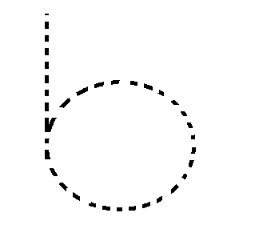**Shade**



**Lesson III**

**Activities**

-Recognition

-Sorting

-Naming

-Shading

**Shade**

**Lesson IV**

Activities

-Identification

-Recitation of letters a – z

-Tracing

**Trace**



**WEEK 9**

**Activities**

-Naming

-Sorting

-Identification

-Matching

**Match the same**

a b

c a

b c

**Lesson II**

**Activities**

-Recitation

-Recognition

-Naming

-Matching

Circle the same letters

a c a

b b e

c d c

**Lesson III**

**Activities**

-Identification

-Recitation

-Practising letter a in air

-Writing letter **‘a’**

**Copy**

a a a

­­­

Lesson IV

**Activities**

-Identification

-Recitation

-Practising letter ‘C’ in air

-Writing letter ‘C’

**Copy**

c c c